Chapter 8
8
of Taxation

APPLICATION: THE COSTS OF TAXATION

WHAT’S NEW IN THE SEVENTH EDITION:

A new In the News box on “The Tax Debate” has been added.

LEARNING OBJECTIVES:

By the end of this chapter, students should understand:

- how taxes reduce consumer and producer surplus.

- the meaning and causes of the deadweight loss from a tax.

- why some taxes have larger deadweight losses than others.

- how tax revenue and deadweight loss vary with the size of a tax.

CONTEXT AND PURPOSE:

Chapter 8 is the second chapter in a three-chapter sequence dealing with welfare economics. In the previous section on supply and demand, Chapter 6 introduced taxes and demonstrated how a tax affects the price and quantity sold in a market. Chapter 6 also described the factors that determine how the burden of the tax is divided between the buyers and sellers in a market. Chapter 7 developed welfare economics—the study of how the allocation of resources affects economic well-being. Chapter 8 combines the lessons learned in Chapters 6 and 7 and addresses the effects of taxation on welfare. Chapter 9 will address the effects of trade restrictions on welfare.
The purpose of Chapter 8 is to apply the lessons learned about welfare economics in Chapter 7 to the issue of taxation that was addressed in Chapter 6. Students will learn that the cost of a tax to buyers and sellers in a market exceeds the revenue collected by the government. Students will also learn about the factors that determine the degree by which the cost of a tax exceeds the revenue collected by the government.

KEY POINTS:

- A tax on a good reduces the welfare of buyers and sellers of the good, and the reduction in consumer and producer surplus usually exceeds the revenue raised by the government. The fall in total surplus—the sum of consumer surplus, producer surplus, and tax revenue—is called the deadweight loss of the tax.

- Taxes have deadweight losses because they cause buyers to consume less and sellers to produce less, and these changes in behavior shrink the size of the market below the level that maximizes total surplus. Because the elasticities of supply and demand measure how much market participants respond to market conditions, larger elasticities imply larger deadweight losses.

- As a tax grows larger, it distorts incentives more, and its deadweight loss grows larger. Because a tax reduces the size of a market, however, tax revenue does not continually increase. It first rises with the size of a tax, but if the tax gets large enough, tax revenue starts to fall.

CHAPTER OUTLINE:

I. The Deadweight Loss of Taxation

A. Remember that it does not matter who a tax is levied on; buyers and sellers will likely share in the burden of the tax.

B. If there is a tax on a product, the price that a buyer pays will be greater than the price the seller receives. Thus, there is a tax wedge between the two prices and the quantity sold will be smaller if there was no tax.

Figure 1
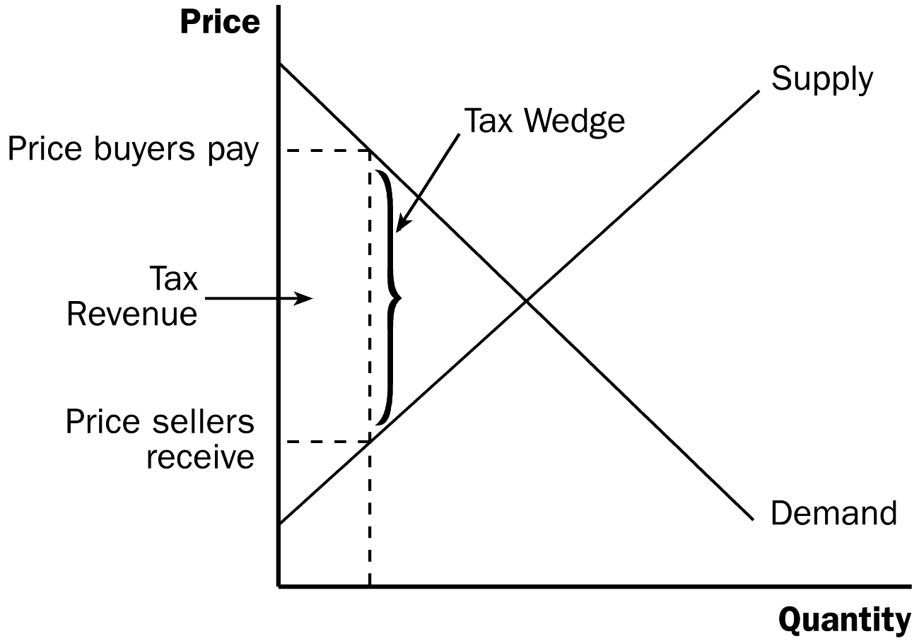

C. How a Tax Affects Market Participants

1. We can measure the effects of a tax on consumers by examining the change in consumer surplus. Similarly, we can measure the effects of the tax on producers by looking at the change in producer surplus.

2. However, there is a third party that is affected by the tax—the government, which gets total tax revenue of T × Q. If the tax revenue is used to provide goods and services to the public, then the benefit from the tax revenue must not be ignored.

If you spent enough time covering consumer and producer surplus in Chapter 7, students should have an easy time with this concept.

Figure 2

3. Welfare without a Tax
Figure 3

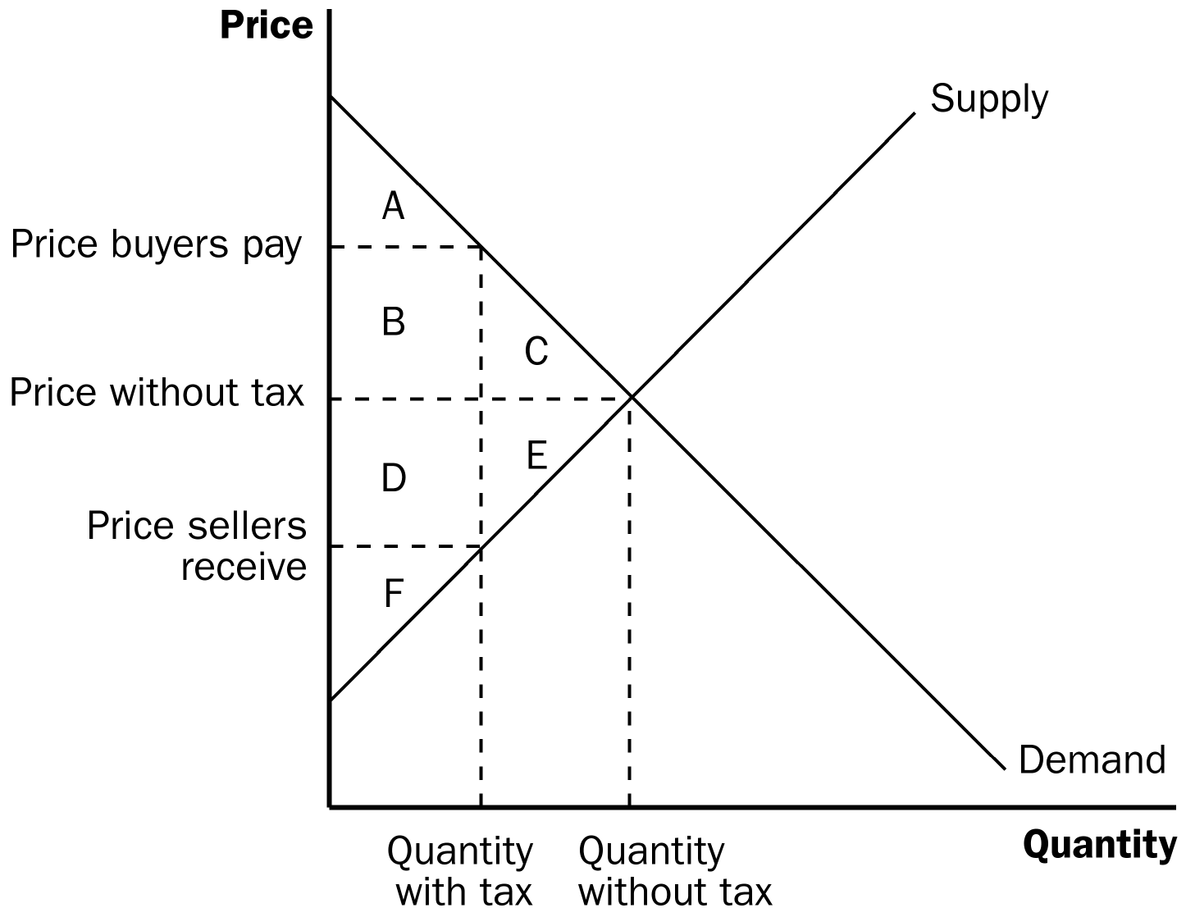

a. Consumer surplus is equal to: A + B + C.

b. Producer surplus is equal to: D + E + F.

c. Total surplus is equal to: A + B + C + D + E + F.

4. Welfare with a Tax

a. Consumer surplus is equal to: A.

b. Producer surplus is equal to: F.

c. Tax revenue is equal to: B + D.

d. Total surplus is equal to: A + B + D + F.

5. Changes in Welfare

a. Consumer surplus changes by: –(B + C).

b. Producer surplus changes by: –(D + E).

c. Tax revenue changes by: +(B + D).

d. Total surplus changes by: –(C + E).

6. Definition of deadweight loss: the fall in total surplus that results from a market distortion, such as a tax.

D. Deadweight Losses and the Gains from Trade
Figure 4

1. Taxes cause deadweight losses because they prevent buyers and sellers from benefiting from trade.

2. This occurs because the quantity of output declines; trades that would be beneficial to both the buyer and seller will not take place because of the tax.
Show the students that the nature of this deadweight loss stems from the reduction in the quantity of the output exchanged. Stress the idea that goods that are not produced, consumed, or taxed do not generate benefits for anyone.

3. The deadweight loss is equal to areas C and E (the drop in total surplus).

4. Note that output levels between the equilibrium quantity without the tax and the quantity with the tax will not be produced, yet the value of these units to consumers (represented by the demand curve) is larger than the cost of these units to producers (represented by the supply curve).

II. The Determinants of the Deadweight Loss

Figure 5

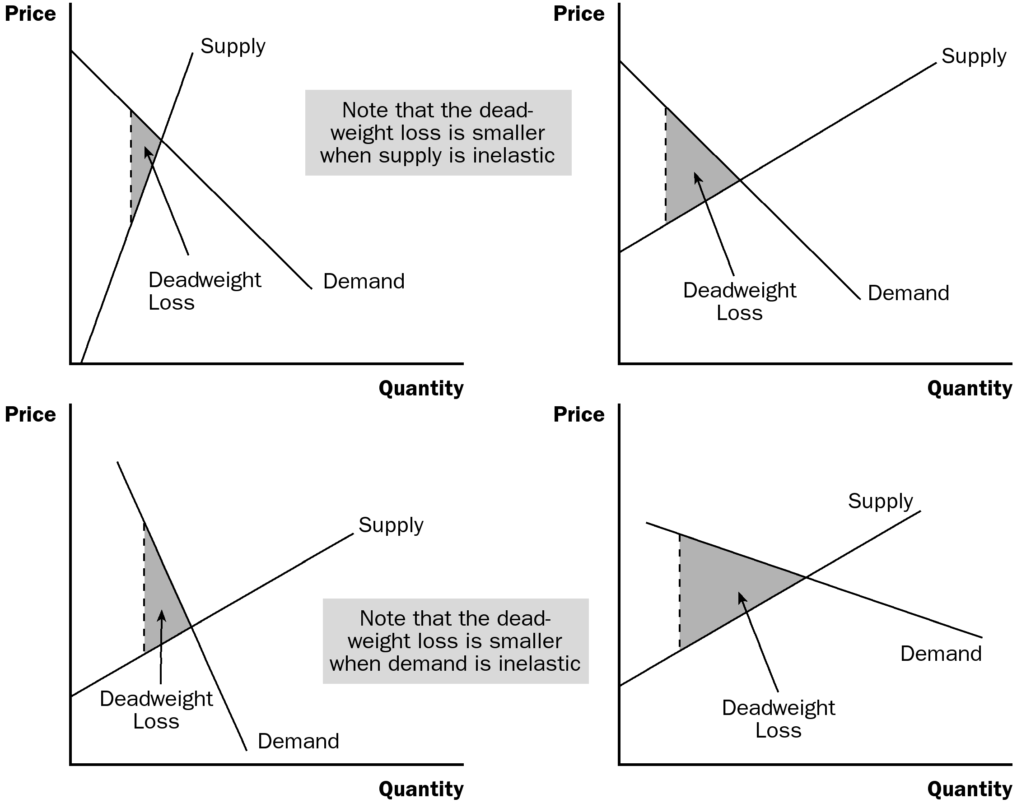

A. The price elasticities of supply and demand will determine the size of the deadweight loss that occurs from a tax.

1. Given a stable demand curve, the deadweight loss is larger when supply is relatively elastic.

2. Given a stable supply curve, the deadweight loss is larger when demand is relatively elastic.

B. Case Study: The Deadweight Loss Debate

1. Social Security tax and federal income tax are taxes on labor earnings. A labor tax places a tax wedge between the wage the firm pays and the wage that workers receive.

2. There is considerable debate among economists concerning the size of the deadweight loss from this wage tax.

3. The size of the deadweight loss depends on the elasticity of labor supply and demand, and there is disagreement about the magnitude of the elasticity of supply.

a. Economists who argue that labor taxes do not greatly distort market outcomes believe that labor supply is fairly inelastic.

b. Economists who argue that labor taxes lead to large deadweight losses believe that labor supply is more elastic.

Activity 1—Labor Taxes

Type: In-class discussion
Topics: Deadweight loss, taxation
Materials needed: None
Time: 10 minutes
Class limitations: Works in any size class

Purpose
Most students have not spent a great deal of time considering the effects of taxation on labor supply. This in-class exercise gives them the opportunity to consider the effects of proposed tax rates on their own willingness to supply labor.

Instructions
Ask students to assume that they are full-time workers earning $10 per hour, $80 per day, $400 per week, $20,000 per year.

Ask them if they would quit their jobs or keep working if the tax rate was 10%, 20%, 30%,
… (up to 100%).

Keep a tally as they show hands indicating that they are leaving the labor force.

Ask students what they think the “best” tax rate is.

Points for Discussion
Many students have no idea that current marginal tax rates are greater than 30% for many taxpayers.

Students will likely say that a tax rate of zero would be best, but remind them that there would be no roads, libraries, parks, or national defense without at least some revenue raised by the government.

III. Deadweight Loss and Tax Revenue as Taxes Vary
Figure 6

A. As taxes increase, the deadweight loss from the tax increases.

B. In fact, as taxes increase, the deadweight loss rises more quickly than the size of the tax.

1. The deadweight loss is the area of a triangle and the area of a triangle depends on the square of its size.

2. If we double the size of a tax, the base and height of the triangle both double so the area of the triangle (the deadweight loss) rises by a factor of four.

C. As the tax increases, the level of tax revenue will eventually fall.

D. Case Study: The Laffer Curve and Supply-Side Economics

1. The relationship between the size of a tax and the level of tax revenues is called a Laffer curve.

2. Supply-side economists in the 1980s used the Laffer curve to support their belief that a drop in tax rates could lead to an increase in tax revenue for the government.

3. Economists continue to debate Laffer’s argument.

a. Many believe that the 1980s refuted Laffer’s theory.

b. Others believe that the events of the 1980s tell a more favorable supply-side story.

c. Some economists believe that, while an overall cut in taxes normally decreases revenue, some taxpayers may find themselves on the wrong side of the Laffer curve.
ALTERNATIVE CLASSROOM EXAMPLE:
Draw a graph showing the demand and supply of paper clips. (Draw each curve as a 45-degree line so that buyers and sellers will share any tax equally.) Mark the equilibrium price as $0.50 (per box) and the equilibrium quantity as 1,000 boxes. Show students the areas of producer and consumer surplus.

Impose a $0.20 tax on each box. Assume that sellers are required to “pay” the tax to the government. Show students that:

- the price buyers pay will rise to $0.60.
- the price sellers receive will fall to $0.40.
- the quantity of paper clips purchased will fall (assume to 800 units).
- tax revenue would be equal to $160 ($0.20 × 800).

Have students calculate the area of deadweight loss. (You may have to remind students how to calculate the area of a triangle.)

Show students that as the tax increases (to $0.40, $0.60, and $0.80), tax revenue rises and then falls, and the deadweight loss increases.

E. In the News: The Tax Debate

1. Recently, policymakers have debated the effects of increasing the tax rate, particularly on higher-income taxpayers.

2. These two opinion pieces from The Wall Street Journal present both sides of the issue.

Activity 2—Tax Alternatives

Type: In-class assignment
Topics: Taxes and deadweight loss
Materials needed: None
Time: 20 minutes
Class limitations: Works in any size class

Purpose
The market impact of taxes can be a new concept to many students. This exercise helps them think about the effects of taxes on different goods. Taxes that may be appealing for equity reasons can be distortionary from a market perspective.

Instructions
Tell the class, “The state has decided to increase funding for public education. They are considering four alternative taxes to finance these expenditures. All four taxes would raise the same amount of revenue.” List these options on the board:
1. A sales tax on food.
2. A tax on families with school-age children.
3. A property tax on vacation homes.
4. A sales tax on jewelry.

Ask the students to answer the following questions. Give them time to write an answer, and then discuss their answers before moving to the next question:
A. Taxes change incentives. How might individuals change their behavior because of each of these taxes?
B. Rank these taxes from smallest deadweight loss to largest deadweight loss. Explain.
C. Is deadweight loss the only thing to consider when designing a tax system?

Common Answers and Points for Discussion
A. Taxes change incentives. How might individuals change their behavior because of each of these taxes?
1. A sales tax on food: At the margin, some consumers will purchase less food. Overall food purchases will not decrease substantially because the tax will be spread over a large number of consumers and demand is relatively inelastic.
2. A tax on families with school-age children: No families would put their children up for adoption to avoid taxes. A large tax could have implications for family planning; couples may choose not to have children, or to have fewer children, over time. A more realistic concern would be relocation to other states by mobile families to avoid the tax.
3. A property tax on vacation homes: This tax would be concentrated on fewer households. A large tax would discourage people from buying vacation homes. Developers would build fewer vacation homes in the long run. In many areas, people could choose an out-of-state vacation home to avoid the tax.
4. A sales tax on jewelry: This tax would also be relatively concentrated. People would buy less jewelry, or they would buy jewelry in other states with lower taxes.

SOLUTIONS TO TEXT PROBLEMS:

B. Rank these taxes from smallest deadweight loss to largest deadweight loss.
Lowest deadweight loss—tax on children, very inelastic
Then—tax on food. Demand is inelastic; supply is elastic.
Third—tax on vacation homes Demand is elastic; short-run supply is inelastic.
Most deadweight loss—tax on jewelryDemand is elastic; supply is elastic.

C. Is deadweight loss the only thing to consider when designing a tax system?
No. This can generate a lively discussion. There are a variety of equity or fairness concerns. The taxes on children and on food would be regressive. Each of the taxes would tax certain households at much higher rates than other households with similar incomes.

Quick Quizzes

1. Figure 1 shows the supply and demand curves for cookies, with equilibrium quantity Q₁ and equilibrium price P₁. When the government imposes a tax on cookies, the price to buyers rises to P_{B}, the price received by sellers declines to P_{S}, and the equilibrium quantity falls to Q₂. The deadweight loss is the triangular area below the demand curve and above the supply curve between quantities Q₁ and Q₂. The deadweight loss shows the fall in total surplus that results from the tax.

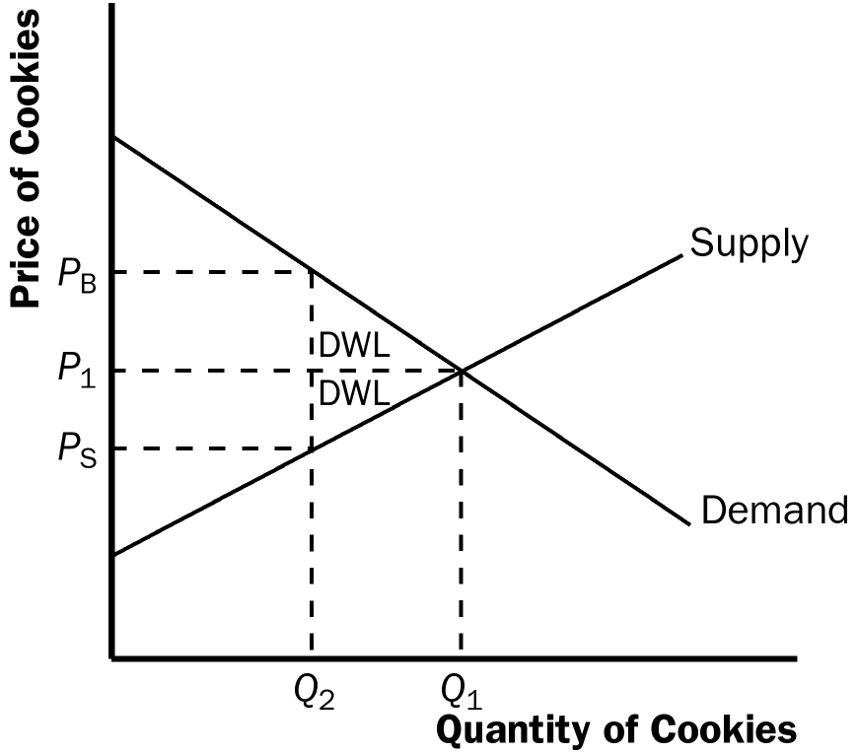

Figure 1

2. The deadweight loss of a tax is greater the greater is the elasticity of demand. Therefore, a tax on beer would have a larger deadweight loss than a tax on milk because the demand for beer is more elastic than the demand for milk.

3. If the government doubles the tax on gasoline, the revenue from the gasoline tax could rise or fall depending on whether the size of the tax is on the upward or downward sloping portion of the Laffer curve. However, if the government doubles the tax on gasoline, you can be sure that the deadweight loss of the tax rises because deadweight loss always rises as the tax rate rises.

Questions for Review

1. When the sale of a good is taxed, both consumer surplus and producer surplus decline. The decline in consumer surplus and producer surplus exceeds the amount of government revenue that is raised, so society's total surplus declines. The tax distorts the incentives of both buyers and sellers, so resources are allocated inefficiently.

2. Figure 2 illustrates the deadweight loss and tax revenue from a tax on the sale of a good. Without a tax, the equilibrium quantity would be Q₁, the equilibrium price would be P₁, consumer surplus would be A + B + C, and producer surplus would be D + E + F. The imposition of a tax places a wedge between the price buyers pay, P_{B}, and the price sellers receive, P_{S}, where P_{B} = P_{S} + tax. The quantity sold declines to Q₂. Now consumer surplus is A, producer surplus is F, and government revenue is B + D. The deadweight loss of the tax is C+E, because that area is lost due to the decline in quantity from Q₁ to Q₂.

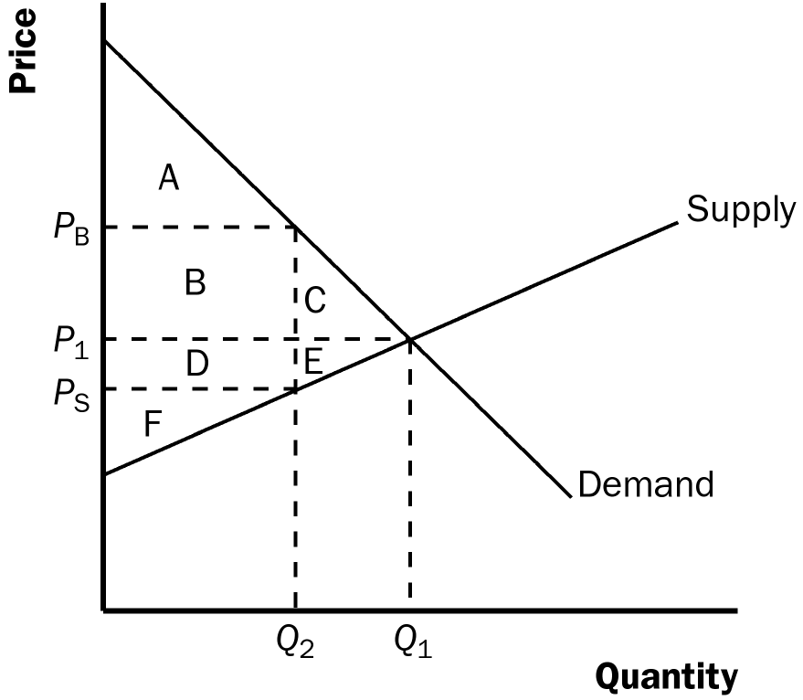

Figure 2

3. The greater the elasticities of demand and supply, the greater the deadweight loss of a tax. Because elasticity measures the responsiveness of buyers and sellers to a change in price, higher elasticity means the tax induces a greater reduction in quantity, and therefore, a greater distortion to the market.

4. Experts disagree about whether labor taxes have small or large deadweight losses because they have different views about the elasticity of labor supply. Some believe that labor supply is inelastic, so a tax on labor has a small deadweight loss. But others think that workers can adjust their hours worked in various ways, so labor supply is elastic, and thus a tax on labor has a large deadweight loss.

5. The deadweight loss of a tax rises more than proportionally as the tax rises. Tax revenue, however, may increase initially as a tax rises, but as the tax rises further, revenue eventually declines.

Quick Check Multiple Choice
1. a
2. b
3. c
4. a
5. b
6. a

Problems and Applications

1. a. Figure 3 illustrates the market for pizza. The equilibrium price is P₁, the equilibrium quantity is Q₁, consumer surplus is area A + B + C, and producer surplus is area D + E + F. There is no deadweight loss, as all the potential gains from trade are realized; total surplus is the entire area between the demand and supply curves: A + B + C + D + E + F.

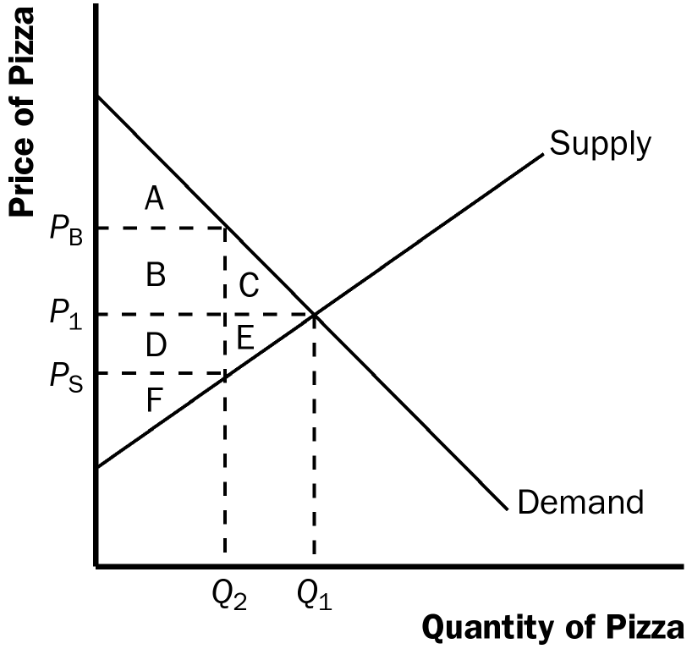

Figure 3

b. With a $1 tax on each pizza sold, the price paid by buyers, P_{B}, is now higher than the price received by sellers, P_{S}, where P_{B} = P_{S} + $1. The quantity declines to Q₂, consumer surplus is area A, producer surplus is area F, government revenue is area B + D, and deadweight loss is area C + E. Consumer surplus declines by B + C, producer surplus declines by D + E, government revenue increases by B + D, and deadweight loss increases by C + E.

c. If the tax were removed and consumers and producers voluntarily transferred B + D to the government to make up for the lost tax revenue, then everyone would be better off than without the tax. The equilibrium quantity would be Q₁, as in the case without the tax, and the equilibrium price would be P₁. Consumer surplus would be A + C, because consumers get surplus of A + B + C, then voluntarily transfer B to the government. Producer surplus would be E + F, because producers get surplus of D + E + F, then voluntarily transfer D to the government. Both consumers and producers are better off than the case when the tax was imposed. If consumers and producers gave a little bit more than B + D to the government, then all three parties, including the government, would be better off. This illustrates the inefficiency of taxation.

2. a. The statement, "A tax that has no deadweight loss cannot raise any revenue for the government," is incorrect. An example is the case of a tax when either supply or demand is perfectly inelastic. The tax has neither an effect on quantity nor any deadweight loss, but it does raise revenue.

b. The statement, "A tax that raises no revenue for the government cannot have any deadweight loss," is incorrect. An example is the case of a 100% tax imposed on sellers. With a 100% tax on their sales of the good, sellers will not supply any of the good, so the tax will raise no revenue. Yet the tax has a large deadweight loss, because it reduces the quantity sold to zero.

3. a. With very elastic supply and very inelastic demand, the burden of the tax on rubber bands will be borne largely by buyers. As Figure 4 shows, consumer surplus declines considerably, by area A + B, but producer surplus decreases only by area C+D..

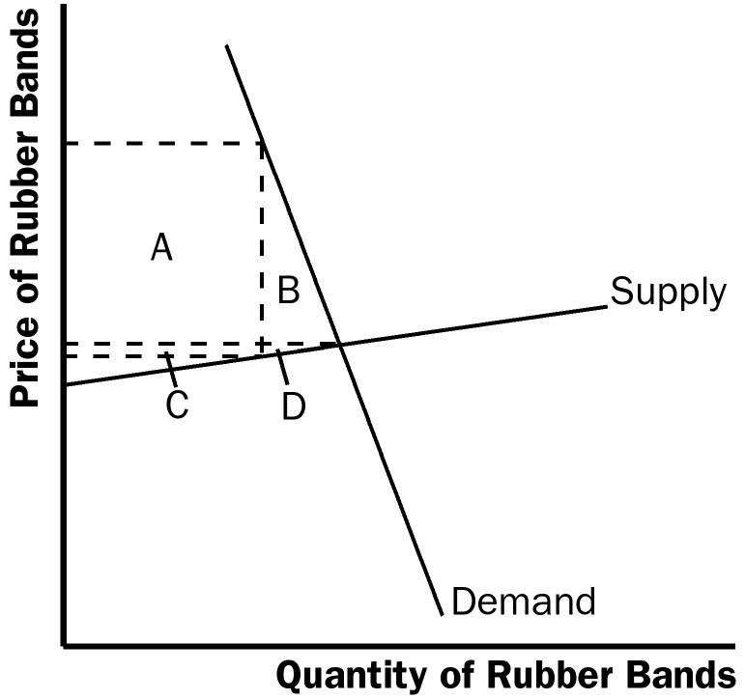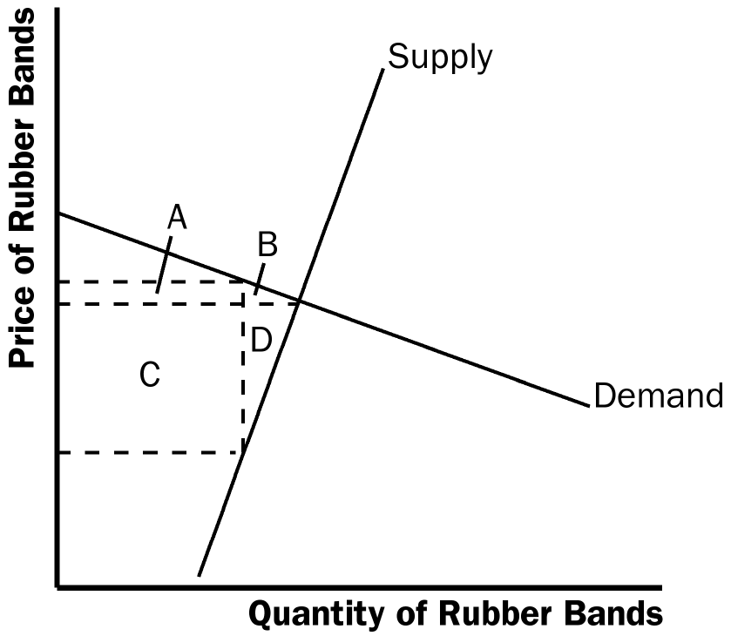

Figure 4 Figure 5

- With very inelastic supply and very elastic demand, the burden of the tax on rubber bands will be borne largely by sellers. As Figure 5 shows, consumer surplus does not decline much, just by area A + B, while producer surplus falls substantially, by area C + D. Compared to part (a), producers bear much more of the burden of the tax, and consumers bear much less.

4. a. The deadweight loss from a tax on heating oil is likely to be greater in the fifth year after it is imposed rather than the first year. In the first year, the demand for heating oil is relatively inelastic, as people who own oil heaters are not likely to get rid of them right away. But over time they may switch to other energy sources and people buying new heaters for their homes will more likely choose gas or electric, so the tax will have a greater impact on quantity. Thus, the deadweight loss of the tax will get larger over time.

b. The tax revenue is likely to be higher in the first year after it is imposed than in the fifth year. In the first year, demand is more inelastic, so the quantity does not decline as much and tax revenue is relatively high. As time passes and more people substitute away from oil, the quantity sold declines, as does tax revenue.

5. Because the demand for food is inelastic, a tax on food is a good way to raise revenue because it leads to a small deadweight loss; thus taxing food is less inefficient than taxing other things. But it is not a good way to raise revenue from an equity point of view, because poorer people spend a higher proportion of their income on food. The tax would affect them more than it would affect wealthier people.

6. a. This tax has such a high rate that it is not likely to raise much revenue. Because of the high tax rate, the equilibrium quantity in the market is likely to be at or near zero.

b. Senator Moynihan's goal was probably to ban the use of hollow-tipped bullets. In this case, the tax could be as effective as an outright ban.

7. a. Figure 6 illustrates the market for socks and the effects of the tax. Without a tax, the equilibrium quantity would be Q₁, the equilibrium price would be P₁, total spending by consumers equals total revenue for producers, which is P₁ x Q₁, which equals area B + C + D + E + F, and government revenue is zero. The imposition of a tax places a wedge between the price buyers pay, P_{B}, and the price sellers receive, P_{S}, where P_{B} = P_{S} + tax. The quantity sold declines to Q₂. Now total spending by consumers is P_{B} x Q₂, which equals area A + B + C + D, total revenue for producers is P_{S} x Q₂, which is area C + D, and government tax revenue is Q₂ x tax, which is area A + B.

b. Unless supply is perfectly elastic or demand is perfectly inelastic, the price received by producers falls because of the tax. Total receipts for producers fall, because producers lose revenue equal to area B + E + F.

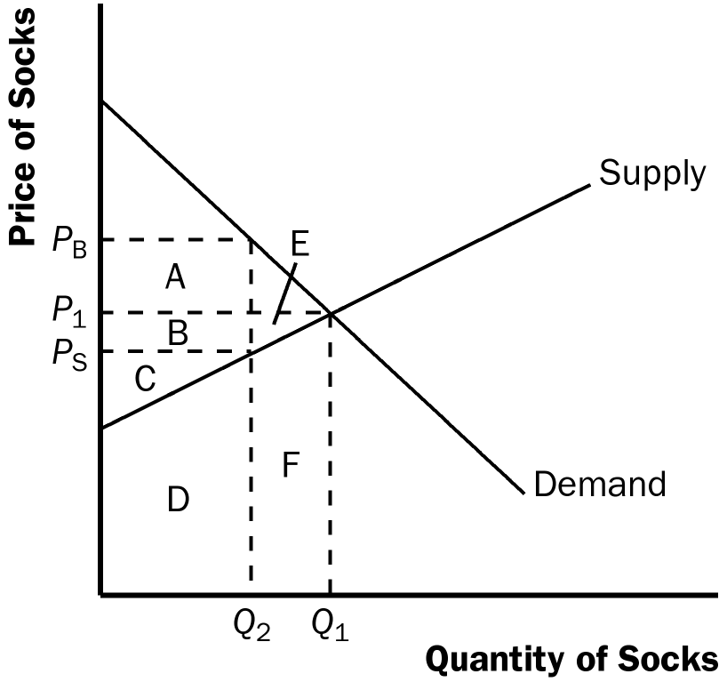

Figure 6

c. The price paid by consumers rises, unless demand is perfectly elastic or supply is perfectly inelastic. Whether total spending by consumers rises or falls depends on the price elasticity of demand. If demand is elastic, the percentage decline in quantity exceeds the percentage increase in price, so total spending declines. If demand is inelastic, the percentage decline in quantity is less than the percentage increase in price, so total spending rises. Whether total consumer spending falls or rises, consumer surplus declines because of the increase in price and reduction in quantity.

8. Figure 7 illustrates the effects of the $2 subsidy on a good. Without the subsidy, the equilibrium price is P₁ and the equilibrium quantity is Q₁. With the subsidy, buyers pay price P_{B}, producers receive price P_{S} (where P_{S} = P_{B} + $2), and the quantity sold is Q₂. The following table illustrates the effect of the subsidy on consumer surplus, producer surplus, government revenue, and total surplus. Because total surplus declines by area D + H, the subsidy leads to a deadweight loss in that amount.

 | Before Subsidy | After Subsidy | Change
Consumer Surplus | A + B | A + B + E + F + G | +(E + F + G)
Producer Surplus | E + I | B + C + E + I | +(B + C)
Government Revenue | 0 | –(B + C + D + E + F + G + H) | –(B + C + D + E + F + G + H)
Total Surplus | A + B + E + I | A + B – D + E – H + I | –(D + H)

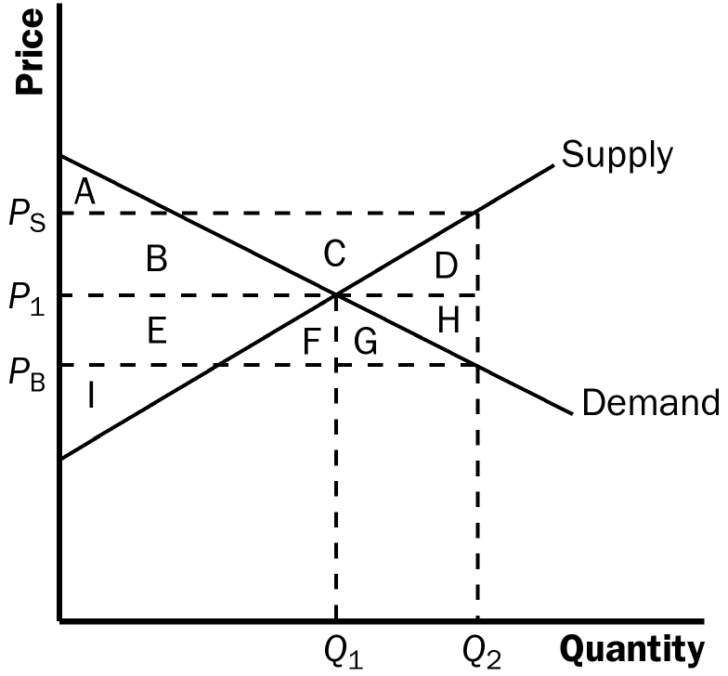

Figure 7

9. a. Figure 8 shows the effect of a $10 tax on hotel rooms. The tax revenue is represented by areas A + B, which are equal to ($10)(900) = $9,000. The deadweight loss from the tax is represented by areas C + D, which are equal to (0.5)($10)(100) = $500.

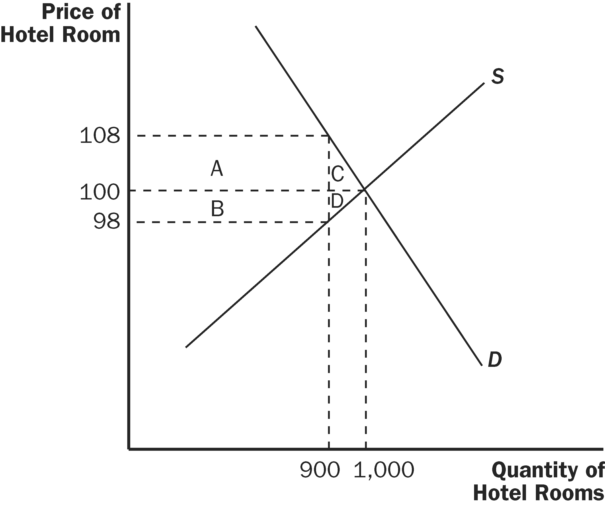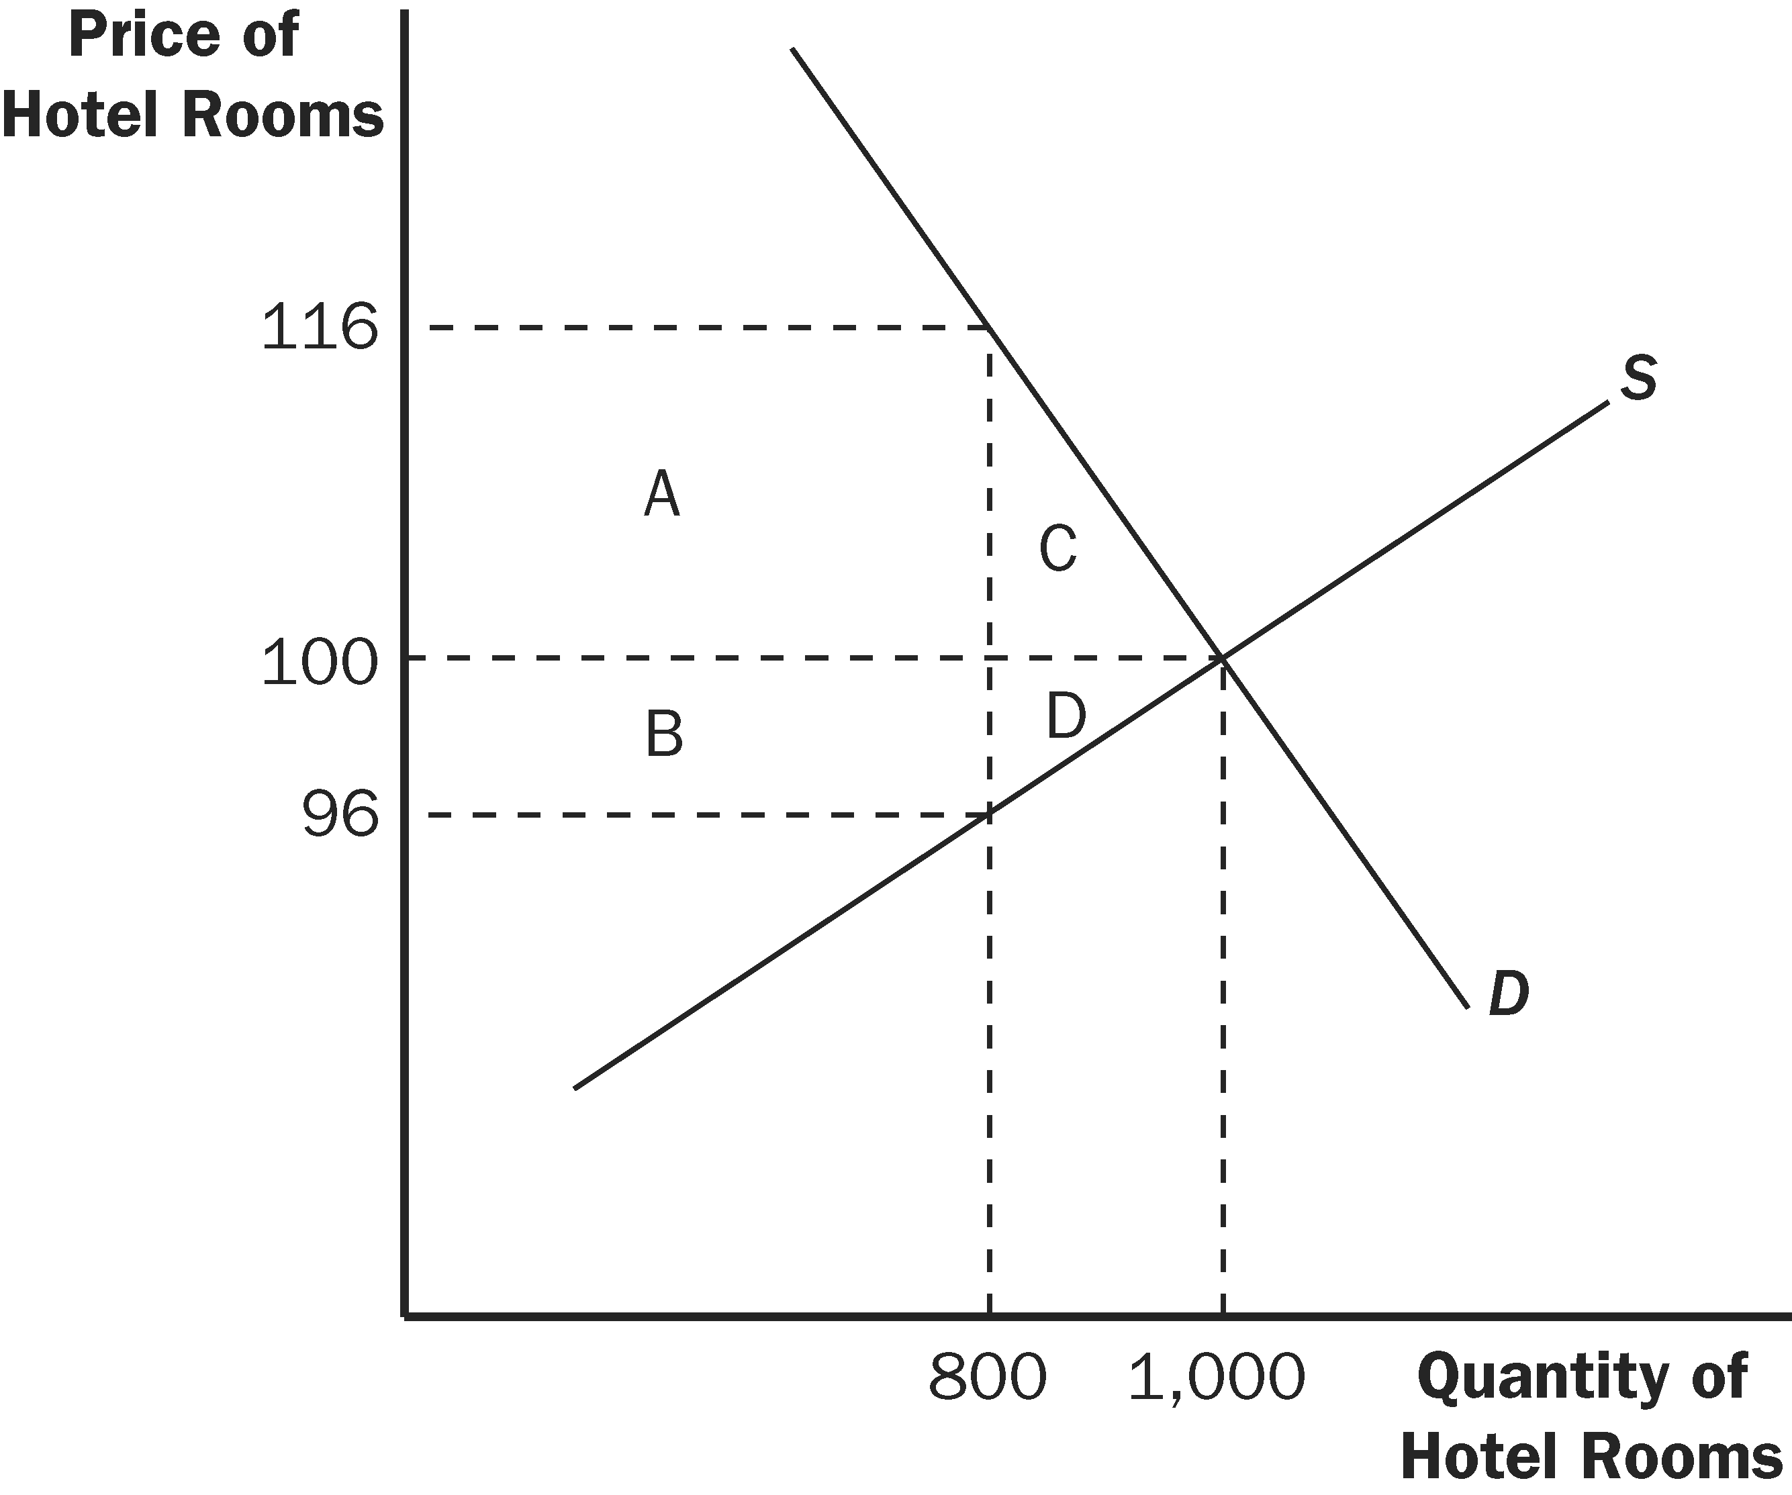

Figure 8 Figure 9

b. Figure 9 shows the effect of a $20 tax on hotel rooms. The tax revenue is represented by areas A + B, which are equal to ($20)(800) = $16,000. The deadweight loss from the tax is represented by areas C + D, which are equal to (0.5)($20)(200) = $2,000.

When the tax is doubled, the tax revenue rises by less than double, while the deadweight loss rises by more than double. The higher tax creates a greater distortion to the market.

10. a. Setting quantity supplied equal to quantity demanded gives 2P = 300 – P. Adding P to both sides of the equation gives 3P = 300. Dividing both sides by 3 gives P = 100. Substituting P = 100 back into either equation for quantity demanded or supplied gives Q = 200.
b. Now P is the price received by sellers and P +T is the price paid by buyers. Equating quantity demanded to quantity supplied gives 2P = 300 − (P+T). Adding P to both sides of the equation gives 3P = 300 – T. Dividing both sides by 3 gives P = 100 –T/3. This is the price received by sellers. The buyers pay a price equal to the price received by sellers plus the tax (P +T = 100 + 2T/3). The quantity sold is now Q = 2P = 200 – 2T/3.

c. Because tax revenue is equal to T x Q and Q = 200 – 2T/3, tax revenue equals 200T − 2T²/3. Figure 10 (on the next page) shows a graph of this relationship. Tax revenue is zero at T = 0 and at T = 300.

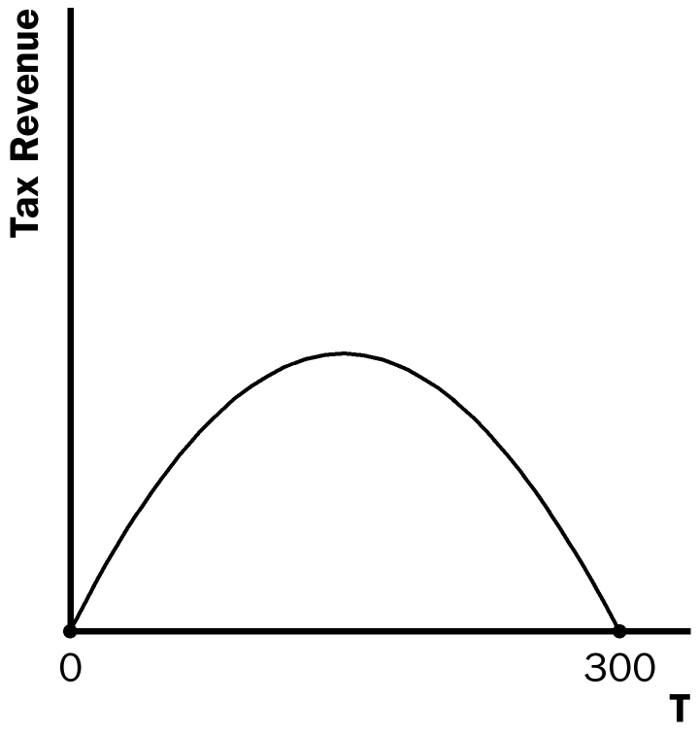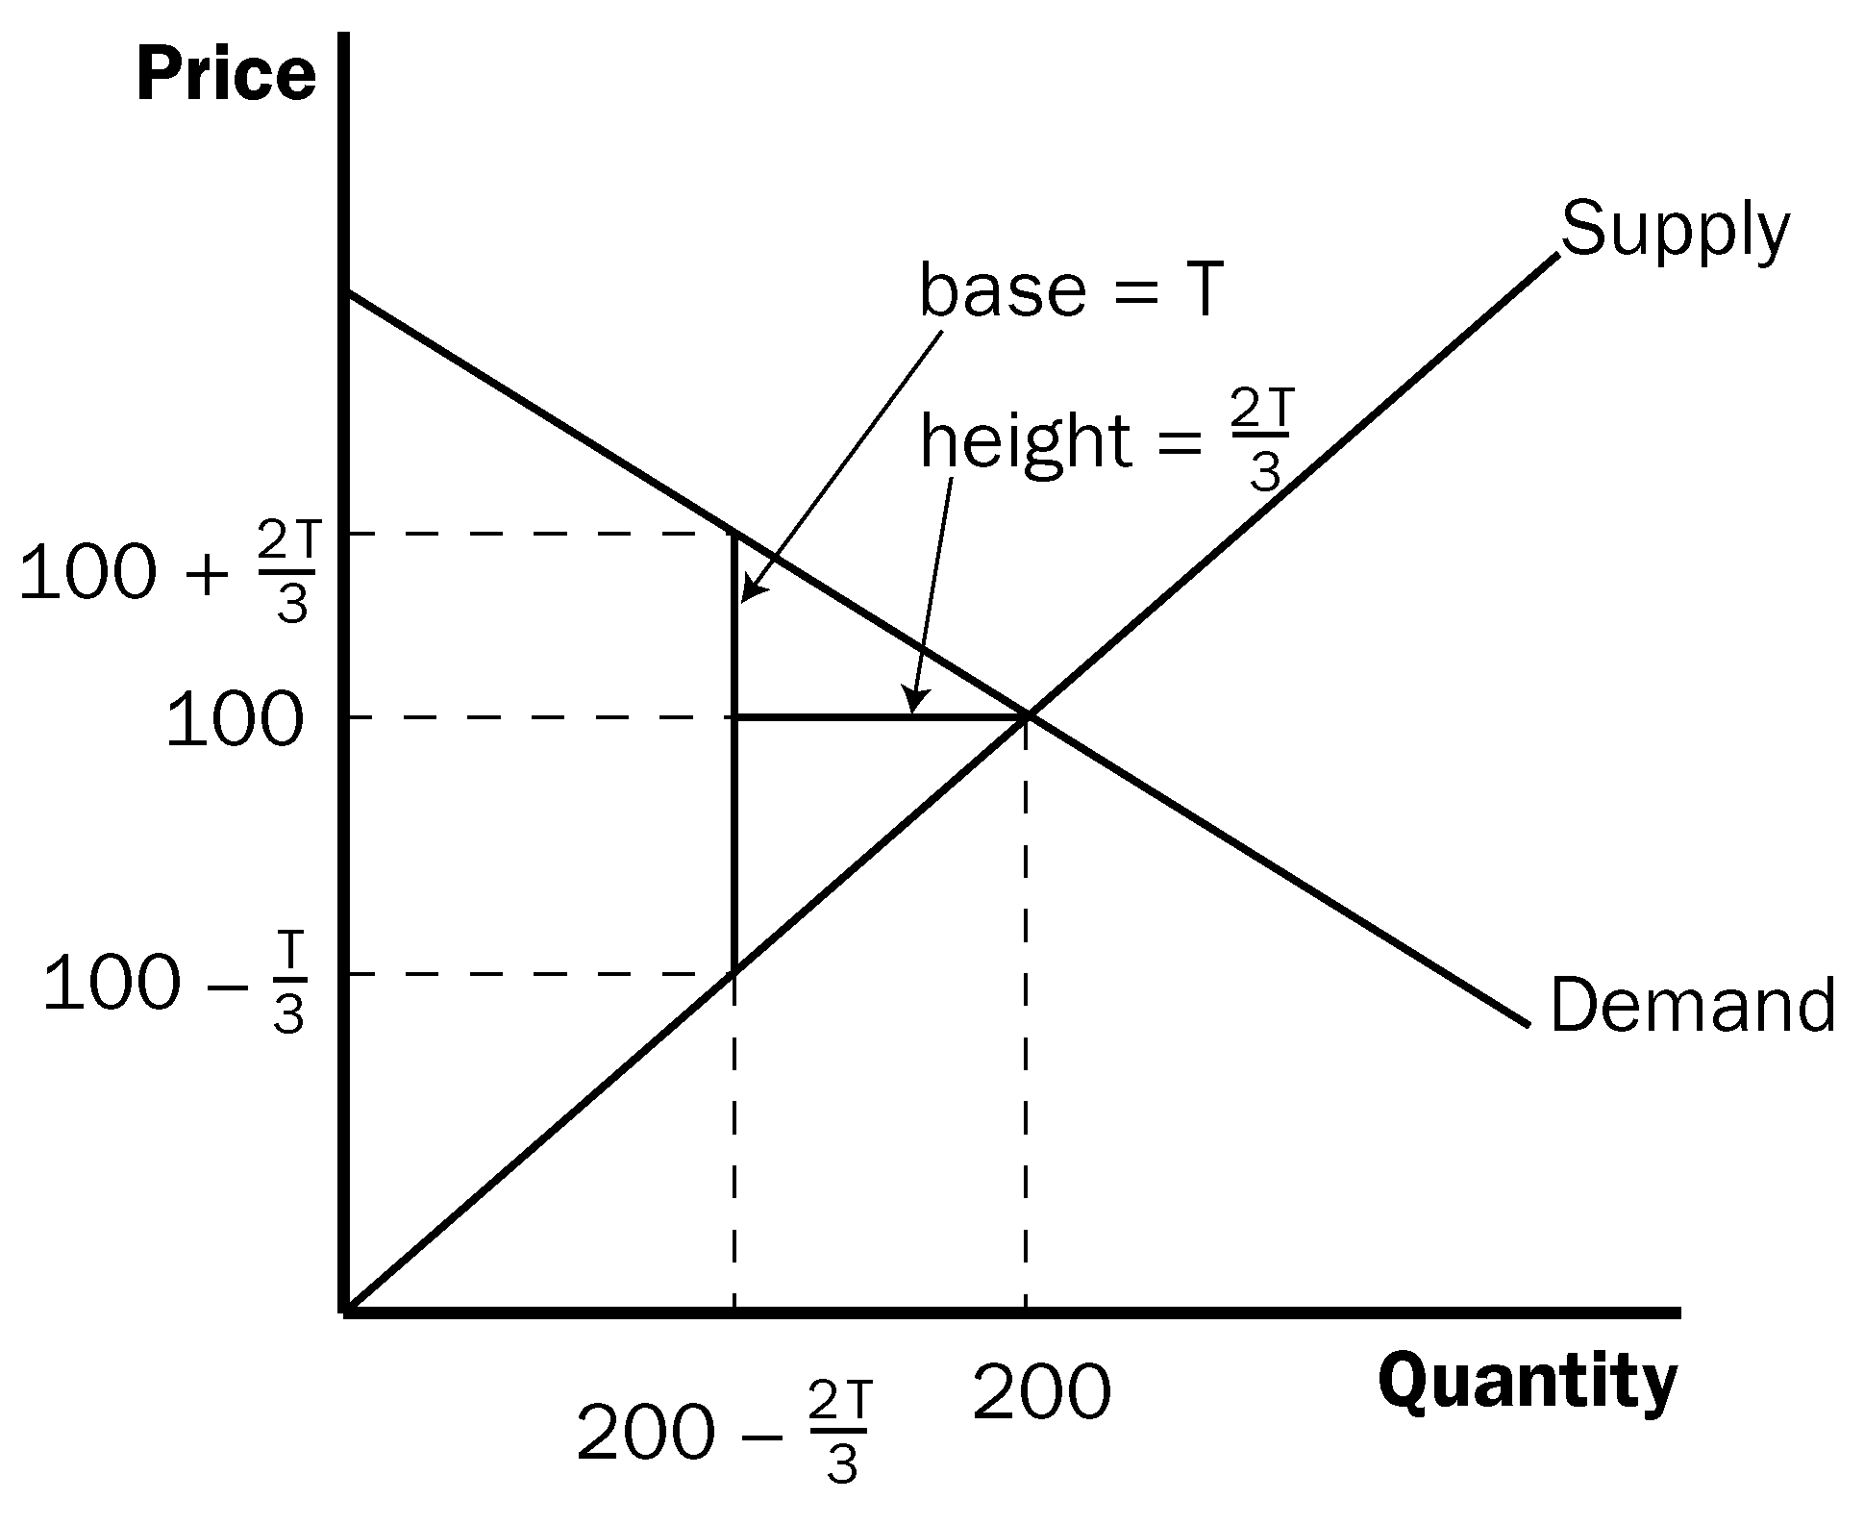

Figure 10 Figure 11

d. As Figure 11 shows, the area of the triangle (laid on its side) that represents the deadweight loss is 1/2 × base × height, where the base is the change in the price, which is the size of the tax (T) and the height is the amount of the decline in quantity (2T/3). So the deadweight loss equals 1/2 × T × 2T/3 = T²/3. This rises exponentially from 0 (when T = 0) to 30,000 when T = 300, as shown in Figure 12.

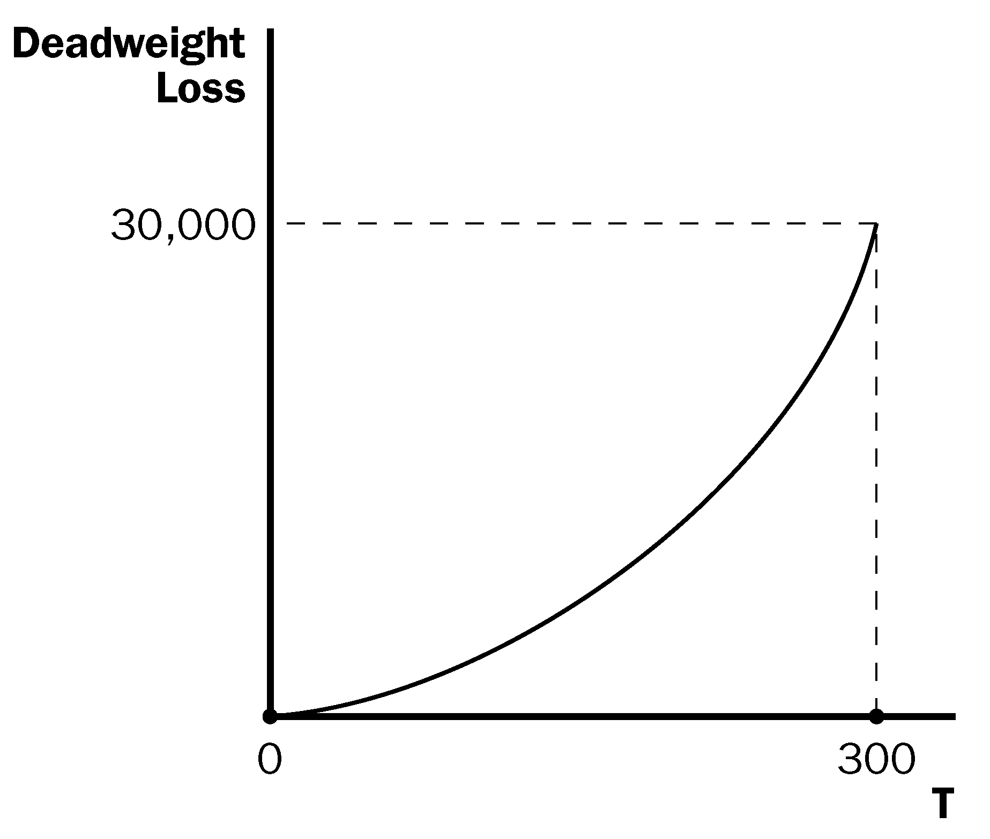

Figure 12

e. A tax of $200 per unit is a bad policy, because tax revenue is declining at that tax level. The government could reduce the tax to $150 per unit, get more tax revenue ($15,000 when the tax is $150 versus $13,333 when the tax is $200), and reduce the deadweight loss (7,500 when the tax is $150 compared to 13,333 when the tax is $200).

